Low Level Design

# Ecommerce Dashboard

|  |  |
| --- | --- |
| **Written By** | Puneet Singh |
| **Document Version** | 1.0 |
| **Last Revised Date** |  |

**DOCUMENT CONTROL**

## Change Record:

|  |  |  |  |
| --- | --- | --- | --- |
| **VERSION** | **DATE** | **AUTHOR** | **COMMENTS** |
| 1.0 | 23-12-2022 | Puneet Singh |  |
|  |  |  |  |
|  |  |  |  |

**Reviews:**

|  |  |  |  |
| --- | --- | --- | --- |
| **VERSION** | **DATE** | **REVIEWER** | **COMMENTS** |
|  |  |  |  |

**Approval Status:**

|  |  |  |  |  |  |
| --- | --- | --- | --- | --- | --- |
| **VERSION** | **REVIEW**  **DATE** | **REVIEWED BY** |  | **APPROVED BY** | **COMMENTS** |
|  |  |  |  |  |  |

# Contents

#### Introduction 04

* 1. **What is Low-Level Design Document? 04**

|  |  |  |
| --- | --- | --- |
| **1.2** | | **Scope 04** |
| **2.** | **Architecture 05** | |
| **3.** | **Architecture Description 06** | |
|  | **3.1** | **Data Description 07** |
|  |

# Introduction

## What is Low-Level design document?

The goal of the LDD or Low-level design document (LLDD) is to give the internal logic design of the actual program code for the House Price Prediction dashboard.

## Scope

Low-level design (LLD) is a component-level design process that follows a step-by-step refinement process.

# Architecture

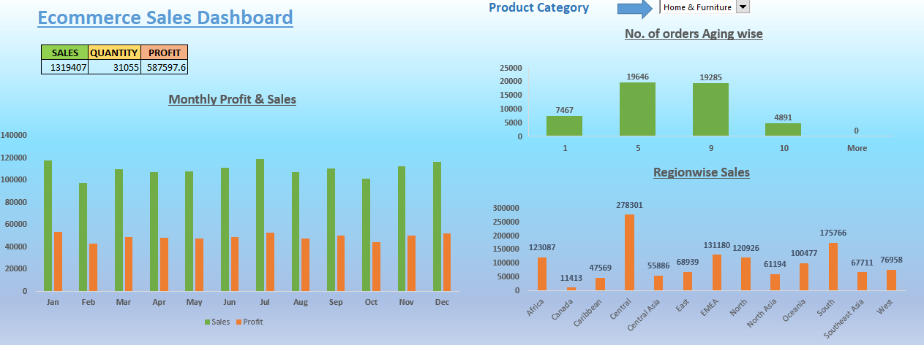

**1.) Monthly Profit & Sales Histogram**

It displays Monthly & Sales data of selected region. It is dynamic in nature.

**2) Region wise Sales Histogram**

It displays region wise sales of particular category selected. It is also dynamic in nature.

1. **No. of orders aging wise**

It displays no. of orders according to no. of days it took to ship those orders.

1. **Sales, Quantity & Profit**

These values are dynamic in nature. They display Sales, profit & Quantity of selected region.

# Architecture Description

## Data Description

The Data set describes complete information about Ecommerce Business

* + 1. Order ID
    2. Order Date
    3. Ship Date
    4. Aging/Shipping days
    5. Ship Mode
    6. Product Category
    7. Product
    8. Sales
    9. Quantity
    10. Discount
    11. Profit
    12. Shipping Cost
    13. Order Priority
    14. Customer ID
    15. Customer Name
    16. Segment
    17. City
    18. State
    19. Country
    20. Region
    21. Months